

**Project CSC343**

**Management Application for a**

**Construction Company**

**F23_08**

**Suliman AlAkeel 441170077**

**Abdullah AlQahtani 441102568**

**Abdulrahman AlMyman 441170135**

**Introduction**

We are working on a management application for a construction company using the skills we learned this semester, such as the functional and non-functional, use case diagram, actor-goal list, class diagram, and activity diagram. The goal of the project is to use each of these technologies on the notion.

**Table of Contents**

|  |
| --- |
| **The functional and non-functional requirements……………………………….…….3** |
| **The actor-goal list………………………………………………………………………………….…4** |
| **The use case diagram……………………………………………………………………………….5** |
| **The use case description………………………………………………………………………….6** |
| **The class diagram…………………………………………………………………………………….8** |
| **The Activity diagram…………………………………………………………………………...….9** |

**The Functional Requirements:**

|  |
| --- |
| 1. The application shouldadd, update, and delete company information. |
| 1. The application shouldview/search company information. |
| 1. The application shouldadd, update, and delete branches information. |
| 1. The application should view/search branches information. |
| 1. The application shouldadd, update, and delete managers information. |
| 1. The application should view/search manages information. |
| 1. The application shouldadd, update, and delete department information. |
| 1. The application should view/Search department information. |
| 1. The application shouldadd, update, and delete information. |
| 1. The application should view/search staff information. |
| 1. The application should add construction site information. |
| 1. The application should update construction site information. |
| 1. The application should delete construction site information. |
| 1. The application should view/search construction site information. |
| 1. The application should assign staff to department. |
| 1. The application should addingdepartment to a branch. |
| 1. The application should addingbranch to company. |
| 1. The application should assigningmanager to branch. |
| 1. The application should assigningconstruction site to a branch. |

**The Non-Functional Requirements:**

|  |
| --- |
| 1. The Application must be implemented on windows 11. |
| 1. The Application must have a user-friendly Gui. |
| 1. The Application should be able to handle a growing number of branches, managers, and staff members. |
| 1. The Application should access control and data protection measures to ensure the confidentiality and integrity of sensitive information. |
| 1. The Application should be reliable and available for use during the company's operational hours. |

**The Actor-Goal Lis:**

|  |  |
| --- | --- |
| **Actor** | **Goal** |
| **Company Manager** | 1. Add, update, and delete company information. 2. View/search company information. 3. Adding branch to company. 4. Assigning manager to branch. |
| **Branch Manager** | 1. Add, update, and delete branches information. 2. View/search branches information. 3. Adding department to a branch 4. Assigning construction site to a branch. |
| **Department Manager** | 1. Add, update, and delete departmentinformation. 2. View/search departmentinformation. 3. Assign staff to department. |
| **Staff Member** | 1. View/search his own information. |
| **Construction Site Manager** | 1. Add, update, and delete construction site information. 2. View/search constructionsiteinformation. |

**The use-case diagram:**

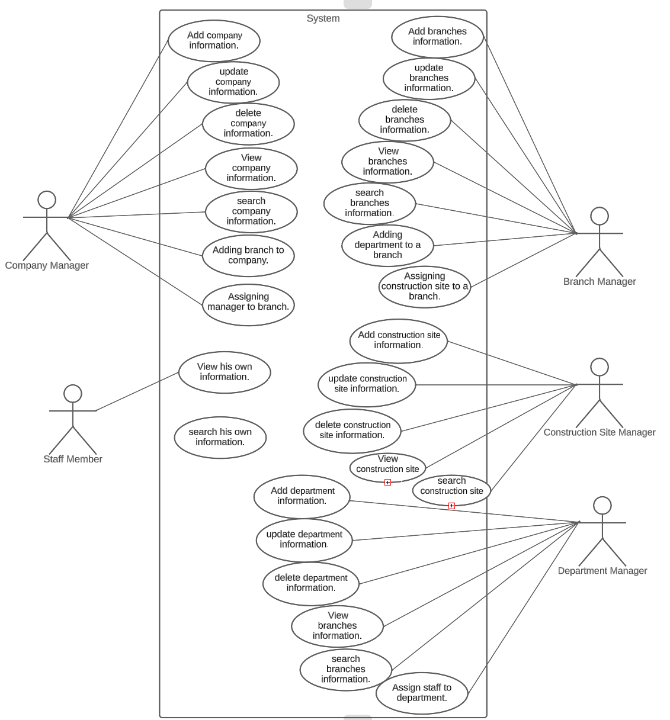

**Description of use-case:**

**Situation:** The company has many branches, and every branch has a manager. One branch can work for different construction sites. Different branches can work on the same construction site. Every Branch will have the same kind of departments and department will have staff members working for that department.

***Use case Name:*** ***Adding Staff to Department***

*Actor: Company Manager*

*Precondition:* Staff has no department.

Post condition: staff are added to Department.

**User Actions System Response**

|  |  |
| --- | --- |
| 1. The Company Manager enters his credentials to the system. | 1. System responses with the validation message. **Exp1** |
| 1. The Company Manager checks if the staff and department’s information are correct and available. | 1. System responses with the availability of staff and department message. **Exp2** |
| 1. The Company Manager Adds the staff to department. **Alt1** | 1. The system responses with the confirmation message. |

**Exception 1: credentials are not validated. No Adding Staff to Department. Use case** ends.

**Exception 2: staff or department are not available. Go to step ii or end the use case.**

**Alternative 1: User directs the system to cancel the operation. Use case ends.**

***Use case Name:*** ***Assigning Construction Site to a branch.***

*Actor: Company Manager*

*Precondition:* Construction site is not assigned to a branch.

Post condition: Construction site is assigned to a branch.

**User Actions System Response**

|  |  |
| --- | --- |
| 1. The Company Manager enters his credentials to the system. | 1. System responses with the validation message. **Exp1** |
| 1. The Company Manager checks if the staff and department’s information are correct and available. | 1. System responds with the availability of construction site and branch message. **Exp2** |
| 1. The Company Manager Assign Construction site to department **Alt1** | 1. The system responses with the confirmation message |

**Exception 1: credentials are not validated. No Assigning** **Construction Site to a branch. Use case ends.**

**Exception 2: Construction Site or branch are not available. Go to step ii or end the use case.**

**Alternative 1: User directs the system to cancel the operation. Use case ends.**

**The class diagram:**

**The Activity Diagram:**

Adding staff to department.

